Case Study

Affiliate Setup on WordPress Overview:
eCommerce Retailer ABC is a successful online store that sells a variety of products through its WordPress-based website. To expand its reach and boost sales, the company decides to implement an affiliate marketing program. This case study explores how eCommerce Retailer ABC set up and managed an affiliate program using WordPress.

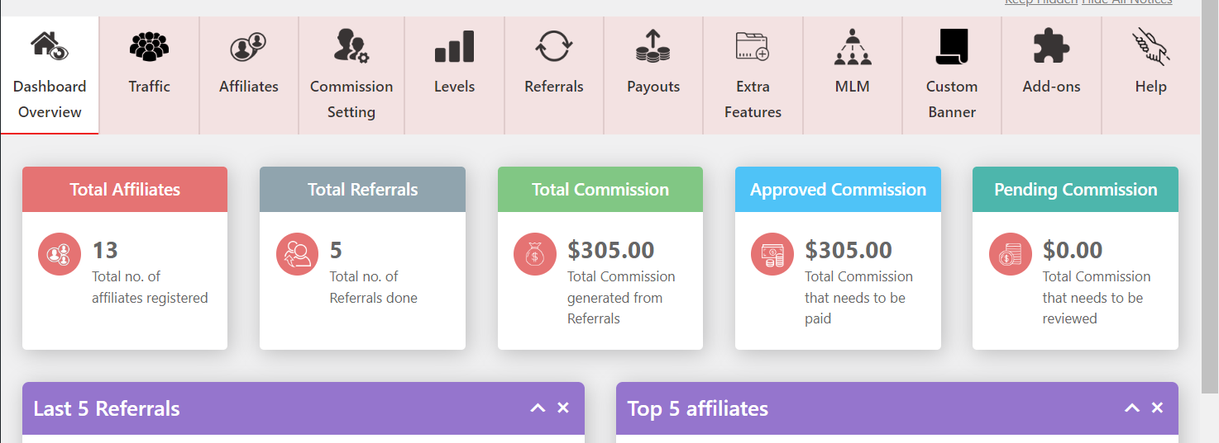

Business Objectives:
The primary objectives of setting up an affiliate program on WordPress are as follows:
a) Increased Sales: Leverage affiliate marketers to promote products and drive more sales through their networks.
b) Extended Reach: Tap into a wider audience by utilizing affiliates' diverse platforms and follower base.
c) Cost-Effective Marketing: Utilize performance-based marketing where affiliates are compensated only when they successfully refer a sale.

Technical Implementation:

Database Queries: We utilizes the WordPress database API and custom SQL queries to retrieve the required data.

Challenges:
Choose Right Plugin : Choosing the right affiliate plugin that meets our needs.

Solution Implementation:

Step 1: Affiliate Plugin Selection
eCommerce Retailer ABC researches and selects a suitable affiliate marketing plugin for WordPress. After evaluating options, they choose a plugin that offers robust features, accurate tracking, and integration with popular e-commerce platforms.

Step 2: Plugin Installation and Configuration
The chosen plugin is installed on the WordPress website. The company configures settings such as commission rates, cookie duration, and payout methods. They also design affiliate registration and dashboard pages for affiliates to join the program and track their performance.

Step 3: Affiliate Onboarding
eCommerce Retailer ABC creates a comprehensive affiliate onboarding process. This includes clear program guidelines, terms of service, and marketing materials for affiliates to promote products effectively.

Step 4: Tracking and Reporting
The affiliate plugin tracks referral links, clicks, conversions, and commissions. eCommerce Retailer ABC regularly monitors the affiliate dashboard to gain insights into affiliate performance, successful conversions, and commissions owed.

Step 5: Payment Processing
The company sets up a reliable payment system to ensure accurate and timely commission payouts to affiliates. Payment cycles and methods are clearly communicated to affiliates.

Results and Benefits:
The implementation of the affiliate program on WordPress yields several positive outcomes for eCommerce Retailer ABC:

a) Increased Sales: The affiliate program generates a significant increase in sales as affiliates actively promote products to their audiences.

b) Extended Reach: The affiliate network expands the retailer's reach, reaching new audiences and markets that may not have been accessible otherwise.

c) Cost-Effective Marketing: The retailer only incurs costs when sales are made through affiliates, making the affiliate program a cost-effective marketing strategy.

d) Engaged Affiliates: The well-structured onboarding process and user-friendly affiliate dashboard keep affiliates engaged and motivated to promote products.

Conclusion:
The successful setup of an affiliate program on WordPress allows eCommerce Retailer ABC to tap into a broader audience, increase sales, and leverage a cost-effective marketing strategy. By carefully selecting and configuring the right affiliate plugin, designing an efficient onboarding process, and continuously monitoring affiliate performance, the company demonstrates its commitment to growth and innovation in the competitive e-commerce landscape. The affiliate program's success not only benefits the retailer but also contributes to building lasting partnerships with affiliates who share a vested interest in driving sales and revenue.

